Landcare Broken Hill Inc

Greening the Hill Mk.2
ABC Radio interview No.12 – 16 July 2019

Phyto-remediation
Intro

Many years ago I was a director of a gold exploration company that was searching for gold in East Gippsland in Victoria. Our exploration was using cutting-edge science. We had a scientist team that did not go out with spades and picks and break rocks, rather they went out with secateurs, a mobile chemical-testing laboratory and microscopes. They would go amongst the trees in the exploration area and cut bunches of leaves. Those leaves were then tested to determine whether the trees were growing in area where gold was present. By testing the chemical composition of the leaves, minute traces of gold could be found. When found, it proved that the trees were absorbing, effectively dissolving, gold at microscopic levels and that could be discovered by scientific testing.

Over the last 20 years or so the science of studying the chemical uptake of plants has greatly advanced. It is now accepted science that certain plants will preferentially absorb different trace elements – such as lead.

Phyto-remediation

Accepting that science, there are now researchers at various universities in Australia, particularly the University of Newcastle (UON) and the University of Technology Sydney (UTS), are exploring the extent to which plants can be deliberately planted for the purpose of removing toxic elements from the soil – effectively cleaning the soil of harmful material, such as lead.

This scientific process is called phyto-remediation – which can be translated to mean “restoring balance through plants”. Effectively, using plants to restore a natural and healthy environment by removing harmful chemicals or elements from the soil.

The late New Zealand biologist Professor Robert Richard Brooks was a pioneer in the field.
The team of researchers at the University of Newcastle is led by Professor SueAnne Ware.
The team of researchers at UTS is led by Dr Megan Murray.

Brooks identified several species which he called ‘hyperaccumulators,’ plants that have the ability to remove large quantities of metals from soils. Since the mid-1980s, and increasingly in the past 20 years, phytoremediation has been used as a technique to decontaminate previously toxic sites.

Professor SueAnne Ware from UON has been remediating the heritage-listed former White Bay Power Station, which is a Sydney landmark. It’s a derelict former industrial site which ceased being a powerstation in 1983. Since 2015 the UON team has been experimenting with plants to de-toxify the site so that it can be developed in the future as The Bays Precinct. It is a cooperative project between UON, UTS and UNSW.

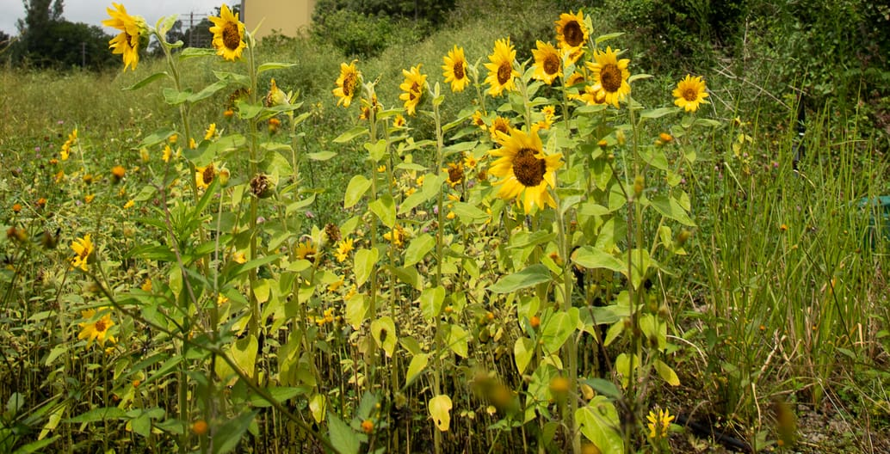

In an article I’ve read from Foreground’s ‘Toxic City’ series, the photos of flourishing sunflowers, one of the best hyperaccumulators, remind me of sunflowers that flower on roadside verges and in the old mine sites in Broken Hill – such as those I always notice near Brown’s Shaft. Their research has confirmed that sunflowers have an ability to extract heavy metals such as arsenic, cadmium, zinc, and nickel.

“In August 2018, the team planted the first Power Plants garden, a 1000-square-metre plot on the eastern side of the White Bay Power Station. They sowed seeds of more than two dozen annual plant species, all proven phytoremediators selected for their capacity to deal with the types of toxins on the site: heavy metals, BTEX (Benzene, Toluene, Ethylbenzene) and pesticides. Some six months later, the carefully planned Garden 01 has turned into a wild meadow in which marigolds, carrots, clover, lupins, mustard and sunflowers, in particular, are flourishing”.

The UTS team has established a research unit called The Phyto Lab. The researchers have a number of exciting and potentially really important projects on the go.

Broken Hill Environmental Lead Program

Because Broken Hill has been mining lead, zinc and silver since the late 19th Century, we know that Broken Hill has a legacy lead pollution problem. That’s why the City has a Lead Smart campaign which is led by the Broken Hill Environmental Lead Program (of which Peter Oldsen is the Project Manager). As part of the Lead Smart campaign, there are a series of guides on their website – one of which is “Live Smart. Backyards and gardens”.

The website material describes the danger of lead to human health. It then gives good advice on how people in Broken Hill should manage their living safely – such as keeping away from bare soil, dirt and dust by covering it and not stirring it up. They advise, as Landcare Broken Hill has been saying, to cover the ground with plants, ground covers or grass.

The website advises that if growing vegetables in Broken Hill, it is best to create raised beds and that the beds be filled with good quality clean soil – that is, not the original Broken Hill soil that you have in your backyard. As Landcare Broken Hill has spoken of, gardeners should use compost and mulch and build up their own best growing medium.

BHELP recommends that any vegetables be thoroughly rinsed before eating to remove dust which may have lead in it. BHELP’s work has largely been focussed on dust in the air carrying lead and adopting practices that keeps the dust down and contains it.

Broken Hill’s Artists in Residence – Rachel Peachey & Paul Mosig

Broken Hill’s current Artists in Residence (see Council Media Release 10 July) are in town to give a new perspective on heavy metals. Their project titled “The Terrestrial Scene” will tell the story of landscape transformation, lead concentration and community response to adversity. It was Rachel & Paul who approached Landcare Broken Hill inviting us to become involved in a phyto-remediation project. We have lept at the idea as we see it as an opportunity of showing how important the growing of plants can be to help clean up the toxic chemicals that lie within the City’s soils – specifically lead.

Members of our Executive Committee are already exploring ideas which will involve the creation of a range of growing beds in which we will experiment with different plants to determine which are the most effective at phyto-remediation. This project could become one of Landcare Broken Hill’s most important at finding an effective way to improve the environment of Broken Hill, making it a healthier and safer place for our citizens to live.

We would hope to collaborate with the universities already doing research in this area.

We can see a day where Landcare Broken Hill’s research into phyto-remediation will enable us to determine which are the best plants to absorb lead in Broken Hill soil. We can then encourage Broken Hill people to grow those plants and we could well propagate them in our community nursery so that there’s a ready supply for people to obtain.

Landcare Broken Hill’s National Tree Day – Sunday 28 July

We are determined to make a positive contribution to Broken Hill on National Tree Day.

We are planning a native seed sowing working-bee on the day, and we will be planting.

Landcare Broken Hill is preparing for a couple of planting projects on the weekend of National Tree Day. Toyota Broken Hill is supporting Landcare and we hope we’ll be joining forces with Broken Hill’s Scouts and other volunteers.

National Tree Day – Sunday 28 July
https://treeday.planetark.org/

We are also seeking sponsors to assist us to buy native plant stock for this year’s planting.

Next public meeting to provide an update on GREENING THE HILL MK.2 and continue of consultation with the community
Centre for Community, 200 Beryl Street, 7.00pm Thursday 25 July

ALL WELCOME!

Want to become a Landcare Broken Hill member?
LandcareBrokenHill@gmail.com

FACEBOOK
www.facebook.com/LandcareBrokenHill/

