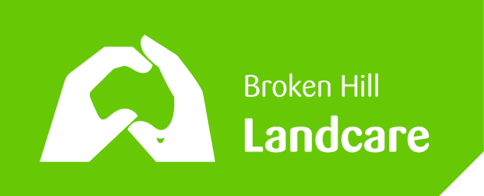 Landcare Broken Hill Inc

Greening the Hill Mk2
ABC Radio interview No.33 – 10 December 2019

REUSE/RECYCLING – AS OLD AS THE HILLS

Today I’d like to talk about the responsible reuse of things – recycling for the benefit of the environment.

Sadly, a lot of people switch off when one talks about sustainability principles, without realising that what we’re talking about is much what their parents and the grandparents and generations before them always did? So today we’ll be doing a little bit of time travel – in the sense of ‘back to future’.

Sometimes people speak of sustainability practices as though they are new, but in reality it might just be new ways of describing sensible old practices. Jargon tends to creep in and for many, like me, jargon is a bit of switch-off. However, for the regulatory sector, in governments and their agencies, sometimes finding the descriptive words is useful.

Modern jargon – Asset Lifestyle planning

‘Asset Lifecycle planning’ is one of those terms which seeks to capture the path of a product from birth to grave. Tracking the assets in a company or organisation is important, especially if there is an obligation at the end of the period of usefulness when the remaining asset must be dealt with – recycled, reused or disposed of. There are people who make a career out of project and asset management life cycle planning.
The key issue is that if there is waste at the end of an asset’s life cycle, it is probably a problem for the environment and a problem for the organisation that has to pay for its final resting place. If that final resting place is a waste dump, then you can probably be sure that they’re wasting some resources. Reusing, recycling should always be the aim – if at all feasible.

In the early days, as generations past we’d always look for ways to reuse everything. If we did so we had less waste but at the same time people made useful things.

Ephemeral Nature of Outback Heritage

I once delivered an address to a national conference of heritage professionals – it was called “The Ephemeral Nature of Outback Heritage”. In that address I described the rather extraordinary effectiveness of people decades and generations ago who would re-use everything they could put their hands on. Nothing lacked the chance of being reused.

I illustrated the talk by describing what happened to the township of Taltingan or Round Hill as it was sometimes called. It is still marked on the Broken Hill topographical map as though it exists, but in the early 1920s it disappeared from the face of the Earth. Why?

The townsfolk just moved everything into Broken Hill. Corrugated houses and their stone footings, every brick, every fashioned stone just ‘walked’. Everything was reused in new locations throughout the township. Today, at the site of old Taltingan, there is absolutely nothing left. Its been re-used and recycled. Minimal waste would result from such old ways.

So let us think about what people used to do (AND STILL CAN DO WITH A LITTLE THOUGHT)

Our grandmothers would reuse all glass jars, such as when she made preservatives, like preserved fruit, or when she did some pickling. Every jar, rather than going into the bin, would be reused time and time again as the seasons passed, for whatever fruit was in season it would go into a reused preserving. Houses used to have a kitchen pantry with shelves heavy with homemade jams, marmalade, preservatives, pickled olives and even the home brew – all most probably in recycled jars & bottles.

I remember that clothes would be reused. Clothes first used for special times would be gradually assigned to rougher wear as they became a touch worn out. So a shirt or jeans might become the gardening clothes or the workshop clothes before their wear-ability came to an end. Then, depending upon the material, if it was fine and colourful, it might be cut up to make a quilted bedspread; or if it was rough and dull, it might end up in the rag bag in the family garage for reuse as a car cleaning cloth or for some dirty mechanical work.

These are simple examples of sustainability principles in practice.

Recently the ABC “War on Waste” documentary revealed that in modern day Australia: “Australians are currently disposing of 6,000 kilograms of fashion and textile waste every 10 minutes”.

The Environment Protection Authority’s around Australia all follow a similar set of principles when it comes to waste avoidance and encouraging us all to reuse and recycle. They refer to a ‘Waste Hierarchy’ – which is a set of priorities for the efficient use of resources
In NSW this waste hierarchy underpins the objectives of the Waste Avoidance and Resource Recovery Act 2001. This is the NSW legislation which sets down the principles and encourages better practices.

The waste hierarchy is:
- avoidance including action to reduce the amount of waste generated by households, industry and all levels of government
- resource recovery including re-use, recycling, reprocessing and energy recovery, consistent with the most efficient use of the recovered resources
- disposal including management of all disposal options in the most environmentally responsible manner.
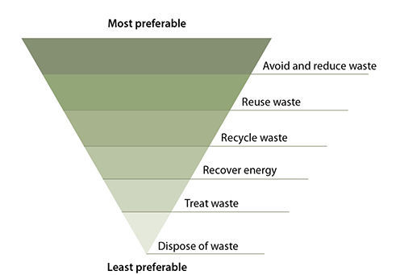

Avoiding and reducing waste
The highest priority, avoiding and reducing the generation of waste, encourages the community, industry and government to reduce the amount of virgin materials extracted and used. The goal is to maximise efficiency and avoid unnecessary consumption through behaviours such as
- selecting items with the least packaging or that require the fewest resources to produce
- avoiding disposable goods or single-use materials
- buying products that are recycled, recyclable, repairable, refillable, re-usable or biodegradable
- using leftover food rather than throwing it away.

Recovering resources - The second priority, resource recovery, maximises options for re-use, recycling, reprocessing and energy recovery.
Where avoiding and reducing waste is not possible, the next most preferred option is to re-use the materials without further processing, avoiding the costs of energy and other resources required for recycling. For example, many household and industrial items can be repaired, re-used, sold or donated to charities. The work of Vinnies, the Salvos, the Brotherhood of St Lawrence and other charities with Op Shops is so good & necessary.
Re-use (without further processing) and recycling (processing waste materials to make the same or different products) keeps materials in the productive economy and benefits the environment by decreasing the need for new materials and waste absorption.
Where further recycling is not feasible, it may be possible to recover the energy from the material and feed that back into the economy where this is acceptable to the community.
Some materials may be inappropriate to re-use, recycle or recover for energy and instead require treatment to stabilise them and minimise their environmental or health impacts.

Treatment or disposal - Finally, the waste hierarchy recognises that some types of waste, such as hazardous chemicals or asbestos, cannot be safely recycled and direct treatment or disposal is the most appropriate management option.

SO THIS CHRISTMAS, LET’S ALL THINK OF CLEVER WAYS BY WHICH WE CAN GIVE THINGS A SECOND CHANCE. MOST OF US KEEP OUR CHRISTMAS DECORATIONS FOR USE IN FUTURE YEARS. LET’S DO MORE & GIVE A GIFT TO THE ENVIRONMENT BY THINKING ABOUT REDUCING OUR CHRISTMAS WASTE BY REUSING ALL THOSE GOOD THINGS WE CAN USE AGAIN NEXT CHRISTMAS.
The next public meeting of Landcare Broken Hill will be early in 2020

In the meantime everyone can keep in contact via:

FACEBOOK: www.facebook.com/LandcareBrokenHill/
WEBPAGE: www.LandcareBrokenHill.com
Email: LandcareBrokenHill@gmail.com
POST: PO BOX 536, BROKEN HILL, NSW, 2880

