COMPLAINTS Policy
Policy number | 5 | Version | 5.0
Drafted by | Dianne Nixon | Approved by Board on | -/-/21
Responsible person | Simon Molesworth | Scheduled review date | -/-/24

Purpose
This document sets out
- Landcare Broken Hill’s policy in regard to external complaints
- The governance structures, responsibilities and processes that have been established to give effect to that policy.
Complaints are defined as an expression or statement of dissatisfaction given by an external stakeholder eg. donor, member of the public. A complaint may be written or verbal, formal or informal, and may occur on social media or in person. Where it involves an internal issue between staff members, members, or volunteers, it is considered a grievance and the Grievance Policy and Procedure should be followed.

Policy
Landcare Broken Hill provides a safe and effective service to those who wish to make a complaint to or about the organisation, whether regarding mismanagement of people’s information and data, use of donations, costs of fundraising or fundraising methods, the provision of services or the quality of the service.
Complaints may happen for many reasons, for example: because of alleged services failures, if relevant information is not readily available, if information is difficult to understand, incomplete or misleading or does not appropriately address common concerns, when answers to frequently asked questions are not provided or made available within a reasonable period of time.
Whatever the reason for a complaint, Landcare Broken Hill sees it as an opportunity to improve the quality of our services and our accountability. Complainants will always be treated with respect and the issue, alleged or real, resolved promptly.

Authorisation
<<Signature of Board Secretary>>
<<Date of approval by the Board>>
Landcare Broken Hill

COMPLAINTS Procedures

Procedure number | 5 | Version | 5.0
Drafted by | Dianne Nixon | Approved by CHAIR on | -/-/21
Responsible person | Simon Molesworth | Scheduled review date | -/-/24

RELEVANT LEGISLATION
Community Services (Complaints, Reviews and Monitoring) Act 1993 (NSW)

Responsibilities
Who | Commitment | How
Chair | Promote a culture that values complaints and their effective resolution | Report to the committee on complaint handling processes.  Provide adequate support and direction to key staff/ members in relation to handling complaints.  Regularly review reports about complaint trends and issues arising from complaints.  Encourage all staff/ members/ volunteers to be alert to complaints and assist those responsible for handling complaints to resolve them promptly.  Encourage staff/ members/ volunteers to make recommendations for system improvements.  Support recommendations for service, staff and complaint handling improvements arising from the analysis of complaint data.
Staff/ members whose duties include complaint handling (may include Chair or Committee members). | Demonstrate exemplary complaint handling practices | Treat all people with respect, including people who make complaints.  Assist people to make a complaint, if needed.  Comply with our policy and associated procedures.  Provide regular feedback to management and/or the governing body on issues arising from complaints.  Provide suggestions to management on ways to improve our complaints management system.  Implement changes arising from individual complaints and from the analysis of complaint data as directed by the Chair and Committee.
All staff/ members/ volunteers | Understand and comply with the complaint handling practices. | Treat all people with respect, including people who make complaints.  Be aware of the complaint handling policies and procedures.  Assist people who wish to make complaints access the complaints process.  Be alert to complaints and assist staff handling complaints resolve matters promptly.

PRINCIPLES
An effective complaint handling system must be modelled on the principles of fairness, accessibility, responsiveness, efficiency and integration into organisational culture. It will address the following principles:
People focus: Landcare Broken Hill is committed to seeking and receiving feedback and complaints about our services, systems, practices, procedures, products and complaint handling. Any concerns raised in feedback or complaints will be dealt with within a reasonable time frame.
People making complaints will be:
- provided with information about our complaint handling process and how to access it
- listened to, treated with respect by staff and actively involved in the complaint process where possible and appropriate, and
- provided with reasons for our decision/s and any options for redress or review.
Anonymous Complaints: We accept anonymous complaints if there is a compelling reason to do so and will carry out a confidential investigation of the issues raised where there is enough information provided.
Accessibility: We will ensure that information about how and where complaints may be made to or about us is well publicised, on our website. We will ensure that our systems to manage complaints are easily understood and accessible to everyone, particularly people who may require assistance.
If a person prefers or needs another person or organisation to assist or represent them in the making and/ or resolution of their complaint, we will communicate with them through their representative if this is their wish. Anyone may represent a person wishing to make a complaint with their consent (e.g. advocate, family member, legal or community representative, member of Parliament, another organisation).
Early resolution: Where possible, complaints will be resolved at first contact with us. When appropriate we may offer an explanation or apology to the person making the complaint.
Responsiveness: We will promptly acknowledge receipt of complaints. We will assess and prioritise complaints in accordance with the urgency and/or seriousness of the issues raised. If a matter concerns an immediate risk to safety or security the response will be immediate and will be escalated to the Chair.
We are committed to managing people’s expectations, and will inform them as soon as possible, of the following:
- the complaints process
- the expected time frames for our actions
- the progress of the complaint and reasons for any delay
- their likely involvement in the process, and
- the possible or likely outcome of their complaint.
We will advise people as soon as possible when we are unable to deal with any part of their complaint and provide advice about where such issues and/or complaints may be directed (if known and appropriate).
We will also advise people as soon as possible when we are unable to meet our time frames for responding to their complaint and the reason for our delay.
Objectivity and fairness: We will address each complaint with integrity and in an equitable, objective and unbiased manner. We will ensure that the person handling a complaint is different from any staff member/ member/ volunteer whose conduct or service is being complained about.
Conflicts of interest, whether actual or perceived, will be managed responsibly. In particular, internal reviews of how a complaint was managed will be conducted by a person other than the original decision maker.
Responding flexibly: Our staff/ members/ volunteers are empowered to resolve complaints promptly and with as little formality as possible. We will adopt flexible approaches to service delivery and problem solving to enhance accessibility for people making complaints and/or their representatives.
We will assess each complaint on its merits and involve people making complaints and/or their representative in the process as far as possible.
Confidentiality: We will protect the identity of people making complaints where this is practical and appropriate. Personal information that identifies individuals will only be disclosed or used by us as permitted under the relevant privacy laws, secrecy provisions and any relevant confidentiality obligations.

PROCESSES

Managing unreasonable conduct by people making complaints
We are committed to being accessible and responsive to all people who approach us with feedback or complaints. At the same time our success depends on:
- our ability to do our work and perform our functions in the most effective and efficient way possible
- the health, safety and security of our staff/ members/ volunteers, and
- our ability to allocate our resources fairly across all the complaints we receive.
When people behave unreasonably in their dealings with us, their conduct can significantly affect the progress and efficiency of our work. As a result, we will take proactive and decisive action to manage any conduct that negatively and unreasonably affects us and will support our staff/ members/ volunteers to do the same in accordance with this policy.

The three levels of complaint handling
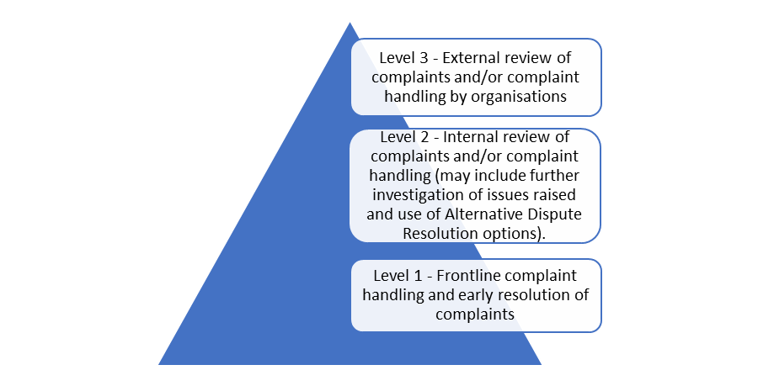
Level 1: We aim to resolve complaints at the first level, the frontline. Wherever possible staff/ members/ volunteers will be adequately equipped to respond to complaints, including being given appropriate authority, training and supervision.
Level 2: Where this is not possible, we may decide to escalate the complaint to a more senior officer within our organisation (Chair or nominated committee member). This second level of complaint handling will provide for the following internal mechanisms:
- assessment and possible investigation of the complaint and decision/s already made, and/or
- facilitated resolution (where a person not connected with the complaint reviews the matter and attempts to find an outcome acceptable to the relevant parties).
Level 3: Where a person making a complaint is dissatisfied with the outcome of our review of their complaint, they may seek an external review of our decision (by the Australian Charities and Not-for-Profits Commission for example).

PROCEDURES
When responding to complaints, staff (paid and volunteer) act in accordance with complaint handling procedures. Staff should also consider any relevant legislation and/or regulations when responding to complaints and feedback.
The five key stages in our complaint management system are set out below:

1 Receive
Unless the complaint has been resolved at the outset, we will record the complaint and its supporting information. We will also assign a unique identifier/number to the complaint file.
The record of the complaint will document:
- Contact information of the person making a complaint and the date received
- Issues raised by the person making a complaint and the outcome/s they want
- Any other relevant information, and
- Any additional support the person making a complaint requires.

2 Acknowledge
We will acknowledge receipt of each complaint promptly, and preferably within 5 working days. When appropriate we may offer an explanation or apology.
Consideration will be given to the most appropriate medium (e.g. email, letter) for communicating with the person making a complaint.

3 Assess and investigate

3.1 Initial assessment
After acknowledging receipt of the complaint, we will confirm whether the issue/s raised in the complaint is/are within our control. We will also consider the outcome/s sought by the person making a complaint and, where there is more than one issue raised, determine whether each issue needs to be separately addressed. When determining how a complaint will be managed, we will consider:
- How serious, complicated or urgent the complaint is
- Whether the complaint raises concerns about people’s health and safety
- How the person making the complaint is being affected
- The risks involved if resolution of the complaint is delayed, and
- Whether a resolution requires the involvement of other organisations.

3.2 Investigating the complaint
After assessing the complaint, we will consider how to manage it. We may:
- Give the person making a complaint information or an explanation
- Gather information about the issue, person or area that the complaint is about, or
- Investigate the claims made in the complaint.
We will keep the person making the complaint up-to-date on our progress, particularly if there are any delays. We will also communicate the outcome of the complaint using the most appropriate medium. Which actions we decide to take will be tailored to each case and take into account any statutory requirements.

4 Determine outcome and provide reasons for decision
Following consideration of the complaint and any investigation into the issues raised, we will contact the person making the complaint and advise them:
- The outcome of the complaint and any action taken
- The reason/s for our decision
- The remedy or resolution/s that we have proposed or put in place, and
- Any options for review that may be available to the complainant, such as an internal review, external review or appeal. We will inform people who make complaints to or about us about any internal or external review options available to them (including any relevant Ombudsman or oversight regulatory bodies).

5 Close the complaint: document and analyse data

5.1 Document
We will keep records about:
- How we managed the complaint
- The outcome/s of the complaint (including whether it or any aspect of it was substantiated, any recommendations made to address problems identified and any decisions made on those recommendations), and
- Any outstanding actions to be followed up, including analysing any underlying or root causes

5.2 Analyse data
We will ensure that outcomes are properly implemented, monitored and reported to the Chair or relevant committee member.

Related Documents
- Anti-Discrimination Policy
- Grievance and Anti-bullying Policy
- Sexual Harassment Policy
- Work Health & Safety Policy
- Code of Ethics
- Broken Hill Landcare Constitution (2021)

Authorisation
<Signature of Chair>
<Name >
<Date>

