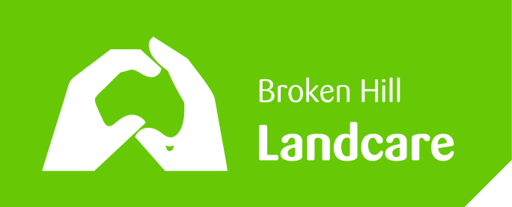 Landcare Broken Hill Inc

Greening the Hill Mk.2
ABC Radio interview No.20 – 10 September 2019

LITTER MANAGEMENT

One of Landcare Broken Hill’s Greening the Hill Mk2 projects has been its proposed Litter Management Project. We are hopeful that in the future we’ll receive a NSW EPA community grant to assist us with our proposed work in this area.

Why does Landcare Broken Hill consider litter is a problem?

It is unsightly. It degrades the bush. It can be a hazard – glass can cut, paper can burn and so cause scrub fires, some rubbish presents a health hazard, some rubbish can be harmful for wildlife.

Litter can so impact on a place that not only locals hate it, but visitors (especially tourists) can be put off. We all agree that our district should be as look and be as good as it possibly can, so as to attract people here to help the local economy.

With the extreme drought we’re experiencing, the emergence of ‘legacy litter’ is becoming very apparent. As plants die they are exposing hidden litter that has been there for long periods. Not only is legacy litter unpleasant and unsightly, once the bush around it dies, the old litter becomes more mobile, being free to be blown about.

Where is litter a problem in the Broken Hill district?

A number of Landcare people have been carrying out informal surveys. We’d like to hear from Broken Hill people where they think litter is a problem.

There are some real hot spots. Truck stop bays on the outskirts of town on most of the seven roads leading into town. It seems that people will stop and drop. Then from those stopping points, along the roadside verges where the wind has blown rubbish further.

Some of the favourite tourist viewing spots

The road off Rakow Street (Barrier Highway) leading to the municipal tip. This is clearly a problem due to people having uncovered loads in trailers and from wind blown rubbish from the tip.

NSW EPA wanted Landcare to carry out Local Litter Checks to compare bad litter sites with like sites which are free of litter. They wanted us to find out what made the difference. It was very difficult to find like sites with differing litter characteristics.

Characteristics of the litter

With the deposits on bottles, cans and plastic drinking containers are less of a problem than in the past, as there is a real incentive for people to collect such litter and make some money.

However, at every spot investigated there was a universal presence of fast food related rubbish. We’ve taken lots of photos at many spots and there was always rubbish from MacDonalds, Hungry Jacks, KFC and Subway. Very disappointing! What can we do about this sort of litter.

There is a behavioural problem here. Why are some people so uncaring? Why do these people not notice that such mess left around, makes the environment less attractive? We have to get at the root cause somehow and start with the family home. We have to engender a more caring attitude from the very start of a young person’s life.

Returning and recycling is a good approach. I recently sat down with the National Sustainability Manager for 7 Eleven Stores Australia. 7 Eleven do not have a store in Broken Hill. He told me about their great recycling programme that started with their coffee cups. It became so successful that they now take cups from all brands and stores. They’ve set up a recycling plant in which they turn the cups into useful products: like park benches, road humps, garden stakes etc. Look at their website.

Rubbish bins – a curse or a blessing

Broken Hill Council has recently introduced new “Smart Bins” which have all sorts of special features – such as automatically sending an electronic signal to Council staff when the bin is full. They also have some means of boosting mobile phone reception. Like the old bins, they also have covered or hooded tops with narrow entrances, so litter can be lifted out of the bins by wind. (In some places such hooded tops are essential to stop birds pulling the litter out – like the ibis throughout Sydney).

Broken Hill bins have no waste separation capacity. Nothing to separate ordinary litter from recyclables, like glass, plastics or cardboard. The Council doesn’t offer a roadside kerb collection of different bins, like in the major cities where each property have a number of bins, each to collect different types of waste. What do Broken Hill people want? Will they separate out different types of waste?

In some places, like in National Parks, they are now withdrawing rubbish bins altogether, relying on

Recently I participated in an environmental field trip to the Royal Melbourne Zoo and examined their state-of-the-art approach to litter and waste management. The separation of waste occurs at every point. Also the avoidance of all plastic is great. No plastic cups, straws or eating utensils.

Signage – warning against littering

Is signage a good thing? The NSW EPA seems to think that signs warning that littering is an offence is a good thing as it discourages people to litter. Other signage is to encourage good conduct – like the statewide campaign “Don’t be a tosser”.

Consulting Landcare Broken Hill members, the unanimous view is that signage is another form of litter – visually littering the landscape with signage. The strong view is that because littering is a behavioural problem out here, then people won’t stop littering simply because there’s a sign nearby.

What does the Broken Hill community think about anti-litter signage?

The Future

For a worthwhile Litter Management Project – there are clearly many issues – much planning needed – and input wanted. Eventually, we’ll need an army of volunteers!!!

The next public meeting which will provide a full overview of GREENING THE HILL MK.2
it will be Landcare Broken Hill’s Annual General Meeting
Centre for Community, 200 Beryl Street, Thursday 26 September 7.00pm

Email: LandcareBrokenHill@gmail.com
FACEBOOK: www.facebook.com/LandcareBrokenHill/
WEBPAGE: www.LandcareBrokenHill.com
POST: PO BOX 536, BROKEN HILL, NSW, 2880

