Landcare Broken Hill Inc

Greening the Hill Mk2
ABC Radio interview No.46 – 7th April 2020

Home projects #1 – Window Gardens

Now that many of us are effectively home bound due to the social distancing now necessary due to COVID-19, from time to time I’m going to be talking about some suggestions for ‘Home Projects’. These will be projects that many people will be able to tackle if they have fairly basic skills and can access some fairly straight forward materials.

The common thread with these projects will be that they are intended to encourage listeners to adopt a more sustainable lifestyle. A number of these projects will be focussed on growing things – greening your own private patch. I’m focussing on these ‘Home Projects’ as I sense a real change in the Australian community.

I’ve had three indicators lately: (1) the local Broken Hill nursery had delivered 3 pallets of potting mix a week or so ago – all the bags on the pallets were sold on the same afternoon of delivery; (2) sellers of vegetable seeds across Broken Hill have been unable maintain enough seed stock before selling out; and (3) the national seed producing club, The Diggers Club, has seen seed orders increase by tens of thousands in the last few weeks, so much so that in the first time in its history, it has had to place a moratorium of new seed orders, in order to give the staff a chance to catch up with orders.

With this extraordinary and terrible pandemic, all of us are experiencing World War like conditions, returning to the days of greater self-sufficiency, greater frugality, less wastefulness and old-fashioned modes of self-reliance. What is happening around us remind one of the stories our grandparents would tell of how they survived in the War years. I am hoping that some of these sensible modes of living remain across the broader community once the pandemic passes.

Window Gardens

Today’s Home Project I’m going to discuss is Window Gardens. Most people are familiar with window boxes – boxes of flowers attached to the external frame of a window. Those who have travelled will have taken photos of delightful period cottages in the UK or in many European countries – picturesque and colourful little window gardens. Scenes in Greek villages and quaint French towns are often picture-perfect with flowering adornments on heritage buildings.

If you are really handy, you can construct window boxes and work out a way of hanging them on the outside of your house. There are commercial window boxes available to purchase, if you’re not good at constructing things – I’ve seen galvanised tin window boxes that look really smart. Buying your window box may be an easy option, but there is a fun alternative to consider.

Today’s project is a simpler proposal – that is to construct a simple table-like plant shelf outside each window you want to improve, either from the viewpoint inside the house or from the viewpoint outside looking at the house. On to this table-like plant shelf you simply place plant pots which you can move around and change.

POSITION

The first issue is to choose your location. There are different perspectives to consider. Those at the front of the house should take into account the aesthetics of the view from the street. With those at the side and the back of the house it is more important to consider the view from inside looking out.

If your house has a narrow pathway down the side, then your design of your plant table can be as narrow as 30cm (about a foot). A practical test to determine how wide your plant table should be, is whether you can take a wheelbarrow or a wheelie bin past.

As for width, a plant table should always be longer than the window is wide. It should project at least 20cm beyond each side of the window. Why? Because the important view is looking out from inside – a person in a room does not always stand directly in front of a window. You might be looking at an angle, left or right. So to take full advantage of a plant table, it should be long enough to offer a view of plants whilst looking on the diagonal.

HEIGHT

In choosing the height of your plant table, you must avoid a common mistake. The plant table must not be built to window sill height, it must be built considerably lower. If the plant table is built to window sill level, you may end up with at least 30cm of window view being nothing other than plant pots. If they are ordinary black plastic pots, you don’t really want to look at a wall of black plastic.

Ideally, all the pots you intend to place on your plant table outside your window should be about the same size. The golden rule is that the top of the rim of any pot plant positioned on the plant table should be below the lower window sill. In this way, looking outside all you see are the plants you want to see and not the pots they are growing in. It is then an attractive verdant green screen you are viewing or seasonal flowers in bloom.

ACCESSIBILITY

The most important aspect of accessibility is to ensure your window plant table can be reached for watering, pruning, feeding or, better still, harvesting.

A really good window plant table location is one beside a window that can be opened to allow a person inside to water the pots on the window plant table. Better still, if you’ve been thoughtful in your plant choice, is to be able to harvest herbs from a kitchen window, by opening the window and clipping some basil, chives, mint or thyme as your culinary skills demand.

PLANT CHOICE

There are a myriad of design alternatives that should guide your choice of plants to be grown in the pots on your window plant table. My preference is to focus on the use of the room which is to have a window garden created for it and then choose your plants to be placed on the window plant table to match your room use.

One consideration, when you’re considering the use of your room with a window and how you want your proposed window garden outside that window to develop, is plant height. Sometimes the view through your window is to something unsightly or might be so proximate to a neighbour’s property, or at least their unshielded window, is that you’d like to grow tall plants to obscure the view. Sometimes your situation might be quite different: you want to retain an attractive view and so you would prefer your window garden to frame the viewscape, in which case you might choose short plants for the centre of your window garden and taller plants for the margins.

My preference for a kitchen window is that it should have outside a mini vegetable and herb garden. Many vegetables and just about all herbs can be grown in pots. What better place to have provisions for the cookpot within reach of the open kitchen window? As most vegetables thrive more readily by having plenty of insect pollinators around, it is always wise to include amongst the vegetable pots at least a couple of other pots assigned to flowering plants known to attract bees like borage or the honey-perfumed allysum.

My own preference for a lounge room, a family room or a dining room window is to have a range of attractive plants which you change according to the season. So, for instance, in spring your pots outside your lounge room window might be filled with bulbs, like daffodils.

If the window by which you have erected a window plant table is to be frequently open, it is wise to include an insect repellent plant amongst your other plants. Tansy is one of the best all-round insect repellent herbs which will deter both mosquitos and flies.

In the context of Broken Hill’s harsh and hot environment, you might like to choose some hardy succulents or cacti that need less watering and can withstand direct hot sun. There is also a wide range of hardy native plants that can be chosen for their stunning sculptural appearance. A good example is the Kangaroo Paw, or Anigozanthos. There are available nowadays a wide range of Kangaroo Paw cultivars, Including dwarf varieties, providing a wide colour range from bright yellow, brilliant green through pinks to the original, but still stunning, red and green.

For those who would like a true bush garden appearance for their pot garden on their window plant table, there is a variety of local native plant species, including peas, grasses and the smaller salt bushes, like ruby saltbush, that can look very attractive, will attract birds to your window and are very low maintenance.

One of the most enjoyable aspects of a window garden comprising pots on a window plant table, is the flexibility you have change the pots around depending upon what looks best at any particular time of the year. Seasonal variation adds variety to your home garden environment and so, as they say, variety is the spice of life!

WATERING

With window gardens, one must be vigilant in understanding the watering requirements of the plants in the pots on your window plant tables. Once you know their needs, never forget them as, more often than not, being located outside a window these plants will be in a very exposed position. Their position is often hotter than elsewhere in the garden, being close to reflected heat from walls of the house and from the window glass itself. Setting up a small dripper system linked to a timer on your nearest tap can be a sensible move, especially if each pot is provided with an individual dripper.

FEEDING

Finally, the whole world of a plant growing in a pot is that pot. Its root can’t go somewhere else in search of nutrients. So you will need to learn the feeding needs of each of your pot plants and be vigilant in not forgetting them. However, a warning, it’s the easiest thing to overfeed a pot plant – primarily because its only soil is that limited within the pot.

Photographs

The first photograph below is of a kitchen window garden I designed in Sydney. With few exceptions, all the plants are either herbs, vegetables or fruit. The tall grass-like plant is the herb lemon grass. Other plants on that window plant table included a finger lime, a blueberry bush, egg plant, basil, mint, thyme, oregano, chives, parsley, kale, silver beet and a climbing passionfruit. Note most of the pots are below the view-line and the neighbour’s brick wall is virtually obscured by the plants, thus softening the view.
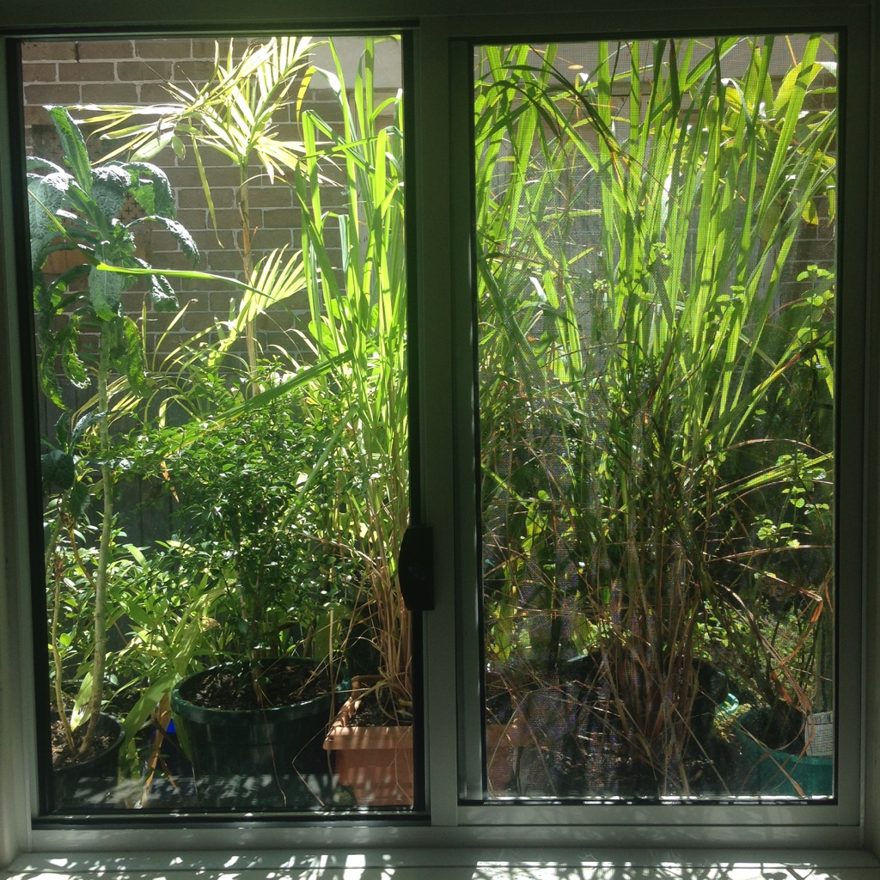

The second photo is of a lounge room window with its window garden designed to obscure a very near neighbour’s fence and their window that provided an unobscured view into our room. The plants included a range of small palms, three small Italian ‘pencil’ cypresses, two banana plants at the periphery and always closest to the glass, seasonal flowering plants. At the time of this photo, the flowering plants selected were begonias, which provided months of brilliant scarlet colour. In early spring the flowering display was of daffodils and jonquils.
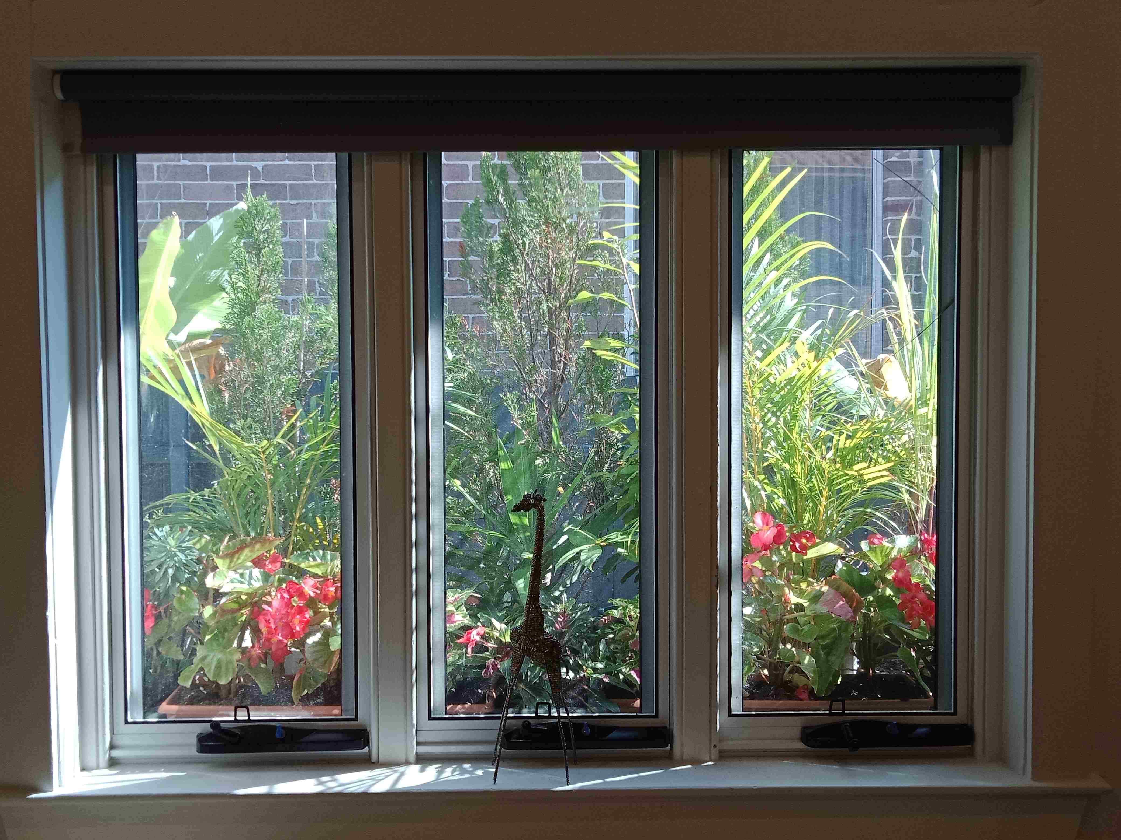
The third and fourth photographs are of the window garden tables constructed out of recycled waste timber. A number of design features are to be noted: (1) the height must be well below the window sill so that pots placed on the window table are below the line of sight looking out through the window; (2) the width must be such that it does not obstruct easy passage past the window garden table; and (3) the top of the window garden table must not be solid, but preferably slatted so as to enable overflow water from the pots to pass on. Buckets placed underneath the slats can collect overflow water for re-use.
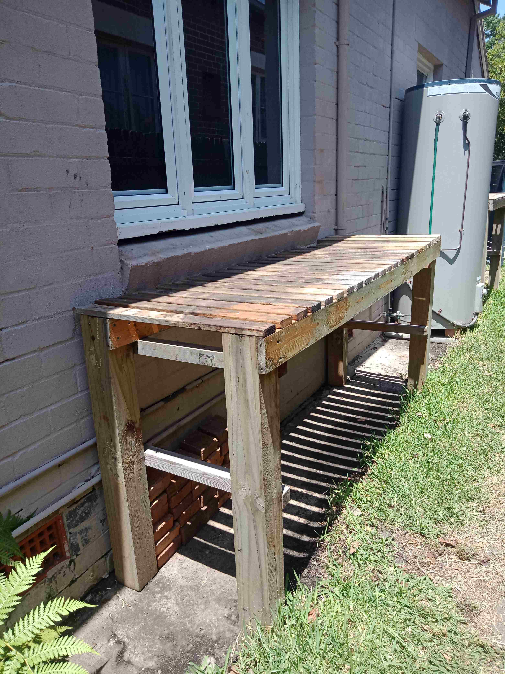

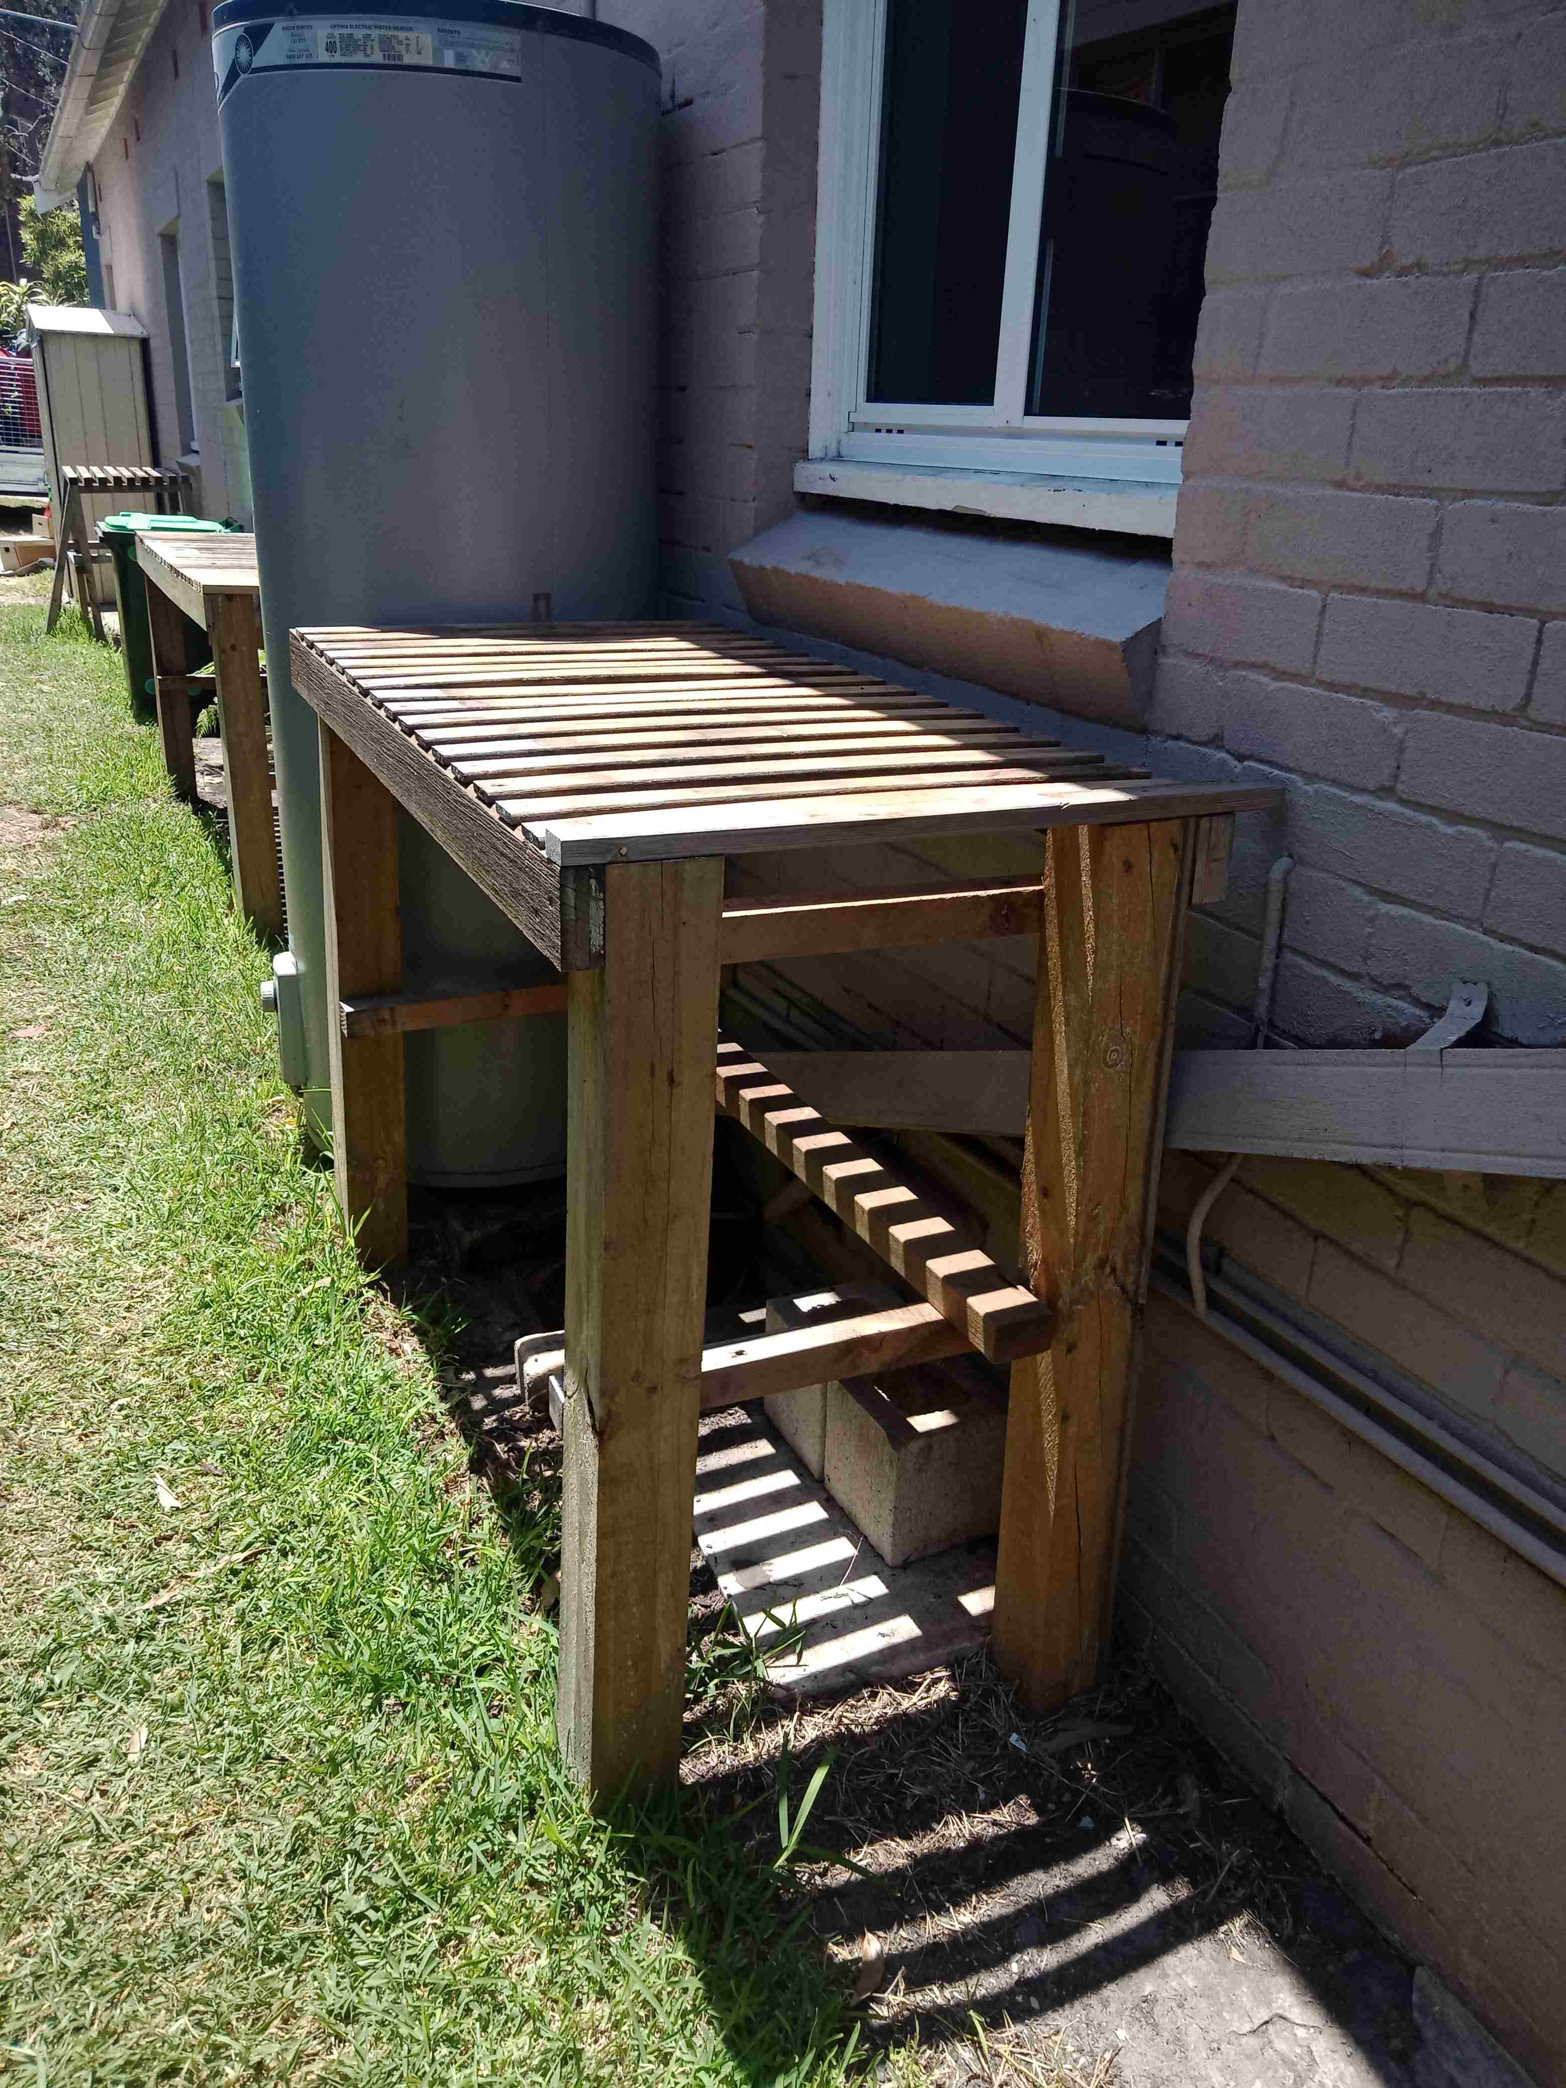

All Landcare Broken Hill’s public meetings have been cancelled for the foreseeable future due to COVID-19.

All Landcare Broken Hill’s on-the-ground projects have been deferred until further notice, although ‘backroom’ planning and preparation continues.

FACEBOOK: www.facebook.com/LandcareBrokenHill/
WEBPAGE: www.LandcareBrokenHill.com
SoundCloud: https://soundcloud.com/user-296305727 - where ABC interviews live on!
Email: LandcareBrokenHill@gmail.com
POST: PO BOX 536, BROKEN HILL, NSW, 2880

