 **Landcare Broken Hill Inc**

***Greening the Hill Mk2***

ABC Radio interview No.47 – 14th April 2020

**Public Project Strategies & Youthful Innovation**

I have regularly talked about Landcare Broken Hill’s 39 projects which together constitute our ***Greening the Hill Mk2*** Initiative. Today I want to talk about how we are now managing our various public projects in the context of the restraints on social interaction as a consequence of the COVID-19 pandemic.

**SUCCESS**

First, a good news story – the **CONSERVATION GARDENS** grant has been confirmed and received. **See attached Media Release from Landcare Australia.**

We’ve mentioned the Conservation Gardens Project a number of times, most recently a month ago when I foreshadowed that we had received an indication that we had been successful.

I’ll recap the details of the Conservation Garden Project.

Sure Gro Tree Max Australia is a true friend of Landcare, as was clearly seen with their support of the NSW State Landcare Conference with their display and their support of trial revegetation plots that were established for one of the Conference field trips.

This Project was to commence this month and be completed with the filing of our final report in December. Obviously with COVID-19 we have had to change our Project timings and delivery expectation.

However, we now have plenty of time for the backroom work, refining project work, ordering materials ands making preparations to be “**shovel ready**”

**This preparing our projects behind the scenes, whilst we’re all in isolation in order to be shovel ready is the approach we must now adopt generally. The *Greening the Hill Mk2* projects are NOT abandoned, they are simply progressing in isolation – much strategic planning is underway.**

Of course, there will be many delays, especially as this season of autumn is the primary planting time in this district. Due to COVID-19 we can’t get out and plant. However, given that the drought has not broken in Broken Hill, it is highly likely that we would not have been able to proceed with planting in this season in any event.

**HOME PROJECTS – Your Patch projects**

Over the last fortnight I’ve been massively increasing the capacity of our vegetable garden on the station. I’m going to give a step by step description of the required steps during a future programme, but for today I wanted to highlight the initiative of one of our Landcare Executive Committee members, our youngest Committee Member – **Jett Collins**

Jett is one of the Broken Hill Young Leaders Group at the Y. In response to considerable interest in ***Greening the Hill Mk2*** from a number of the Young Leaders, at our AGM late last year we altered our Landcare Constitution to permanently reserve 2 seats on our Executive Committee for two young members of our Broken Hill community. Jett is still at school.

Jett has been one of our keenest volunteers at our Community Gardens at the Centre for Community in Beryl Street. He has overseen one of our planting beds, planting his choice. He has produced the most amazing harvest of pumpkins, not just one variety, but a number. Some of his pumpkins were so good, that I’m wondering whether we should set up a vegetable growers’ competition next Spring/Summer.

Jet is now based at home, observing the COVID-19 requirements to stay at home unless there is an essential reason to leave. So what has Jett done with his time? Using the wood that he has recycled out of a couple of packing cases, he has created a wonderful home vegetable patch.

Jett has used his initiative and innovatively shown that in this time of social isolation, his time has been used productively.

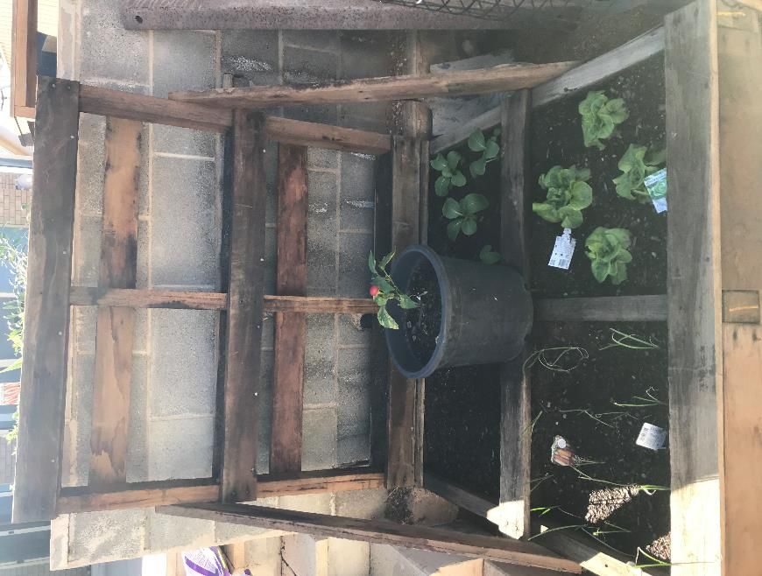

**NEXT WEEK – a return to Home Projects – with Project #2**

Next week, focussing on the community’s **greater self-sufficiency, greater frugality, less wastefulness and old-fashioned modes of self-reliance** I’ll be returning to the home front to talk in detail about another Home Project, following on our talk last week about Window Gardens. As I said last week, my intention on focussing on **Home Projects** is to encourage listeners to adopt a more sustainable lifestyle.

**All Landcare Broken Hill’s public meetings have been cancelled for the foreseeable future due to COVID-19.**

**All Landcare Broken Hill’s on-the-ground projects have been deferred until further notice, although ‘backroom’ planning and preparation continues.**

**FACEBOOK:** [**www.facebook.com/LandcareBrokenHill/**](http://www.facebook.com/LandcareBrokenHill/)

**WEBPAGE:** [**www.LandcareBrokenHill.com**](http://www.LandcareBrokenHill.com)

**SoundCloud:** [**https://soundcloud.com/user-296305727**](https://soundcloud.com/user-296305727) **- where ABC interviews live on!**

**Email:** [**LandcareBrokenHill@gmail.com**](mailto:LandcareBrokenHill@gmail.com)

**POST: PO BOX 536, BROKEN HILL, NSW, 2880**