Landcare Broken Hill Inc

Greening the Hill Mk2
ABC Radio interview No.48 – 23rd April 2020

HOME PROJECTS #2
RAISED BEDS FOR VEGETABLES IN THE ARID ZONE

Fostering greater self-sufficiency, greater frugality, less wastefulness and old-fashioned modes of self-reliance

Today’s talk is the second in my series on Home Projects during the COVID-19 lockdown – focussing on projects that we can do at home. Today I’ll be discussing a few of the steps towards creating raised garden beds for growing vegetables in the Arid Zone.

Due to the harsh climate conditions in the Arid Zone in the Far West of NSW, there are particular challenges that need be addressed:
first, high ambient temperatures for an extended run of months each year; and secondly, the scarcity and expense of water, in the context of a very high evaporation rate.

A third challenge in the Broken Hill region is the condition and characteristics of the soil.

Alkalinity is far too high. The natural soil in and around Broken Hill is terribly poor and is far too alkaline for good vegetable production.

Lead contamination. Further, due to wind-blown dust over many past decades, there has been much deposition of lead contamination from the early mining activity in the region. Before the more modern treatment of the mullock heeps, whereby the mine waste dumps are kept relatively stable, there was a lot of air-borne lead contaminated material settling on the soil in and around Broken Hill

So today I’m going to give some tips to address these issues.

First, water containment. Due to the scarcity of water and its expense if you have to buy it, the approach one needs to take is: (1) reduce the amount of water used; (2) contain the water you use in the most effective way you can; and (3) apply water in a way to ensure you don’t lose too much of it through evaporation.

Secondly, soil condition and avoiding lead contaminants. If you plant your vegetables direct into the natural soil in your Broken Hill garden at the natural soil level, the chances are you will have to tackle heavily alkaline soil and soil that has some lead contamination in it.

Next, some science. Why is high alkalinity in Broken Hill’s soils a problem? pH is a measure of hydrogen ion concentration, a measure of the acidity or alkalinity of a solution. The pH scale usually ranges from 0 to 14. Aqueous solutions at 25°C with a pH less than 7 are acidic, while those with a pH greater than 7 are basic or alkaline. My measurements of soil pH on our property, which I expect will be typical of this district, is a pH of 8 to 9. Most plants prefer to grow in the range of 6 to 7, being fairly neutral pH. If the pH is too high or too alkaline, all the good trace elements that plants require for healthy growth, like iron, zinc and manganese become ‘locked’ up by the high pH, preventing them from growing well. They will become stunted, often discoloured and showing signs of some deficiency.

Most fruit and citrus trees prefer a low pH, of about 6 to 7, that is, slightly acidic. So if your lemon tree has curled leaves and they’re no longer green but shades of yellow, the chances are they are not accessing essential minerals because they suffering from too high alkalinity.

Well what do we do to tackle these issues while you’re getting ready for your COVID-19 isolation Home Project building a veggie garden?

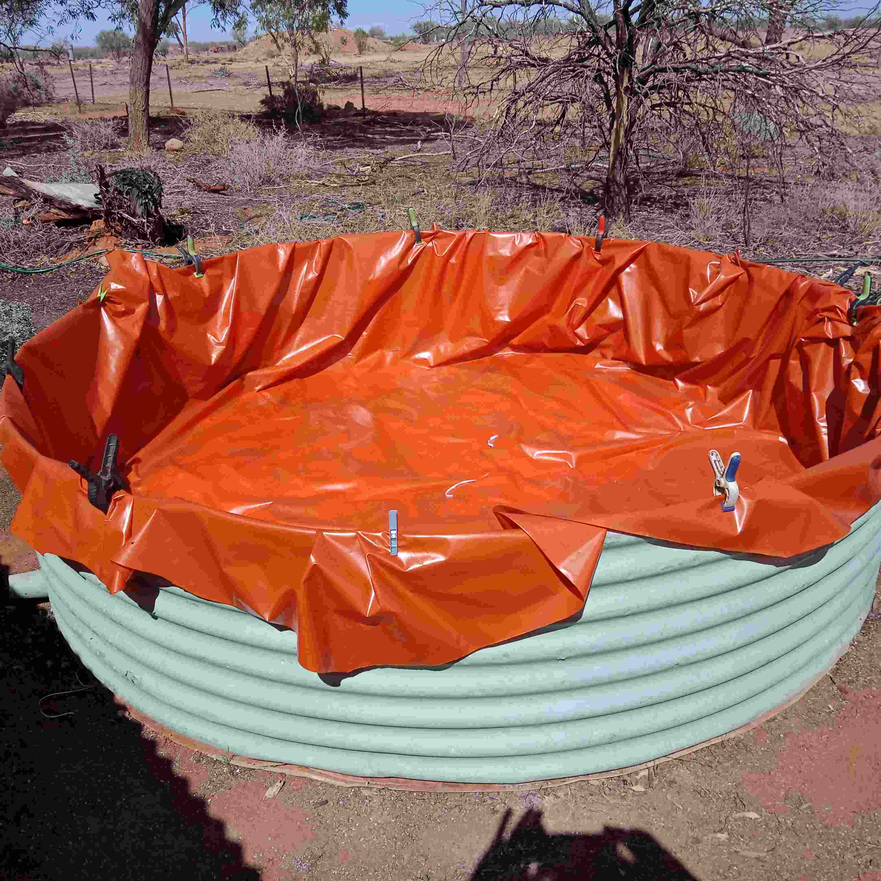 | First, aim to create raised garden beds with all your growing soil on top of the natural level.  How: you can try building your garden beds up with rocks, wooden beams, sleepers or corrugated iron. But this approach invites your garden beds to dry out quickly – you will be battling water loss and high evaporation.  The answer: grow in a sealed container, like an old cut-off water tank. 6 to 8 rings high is best. If you haven’t got a tank, recycle a plastic pod, or find an old bath.  Line your container with thick impervious plastic, rather like making a wading pool.

Then, if you think of the bottom of your old water tank or like container as a well, fill the lower third with friable material. Some people use pebbles, I prefer organic material such as masses of shredded paper and cardboard. An example of reuse or the recycling of what would otherwise be waste  With this material sitting at the base of your tank, but entirely contained within the impervious plastic sealer, it retains any excess water that percolates downwards once your garden is established.  The plastic liner or sheeting in your tank can be held in place by cutting old poly tube or garden hose on its underside and then slipping it over the rim of the old tank | 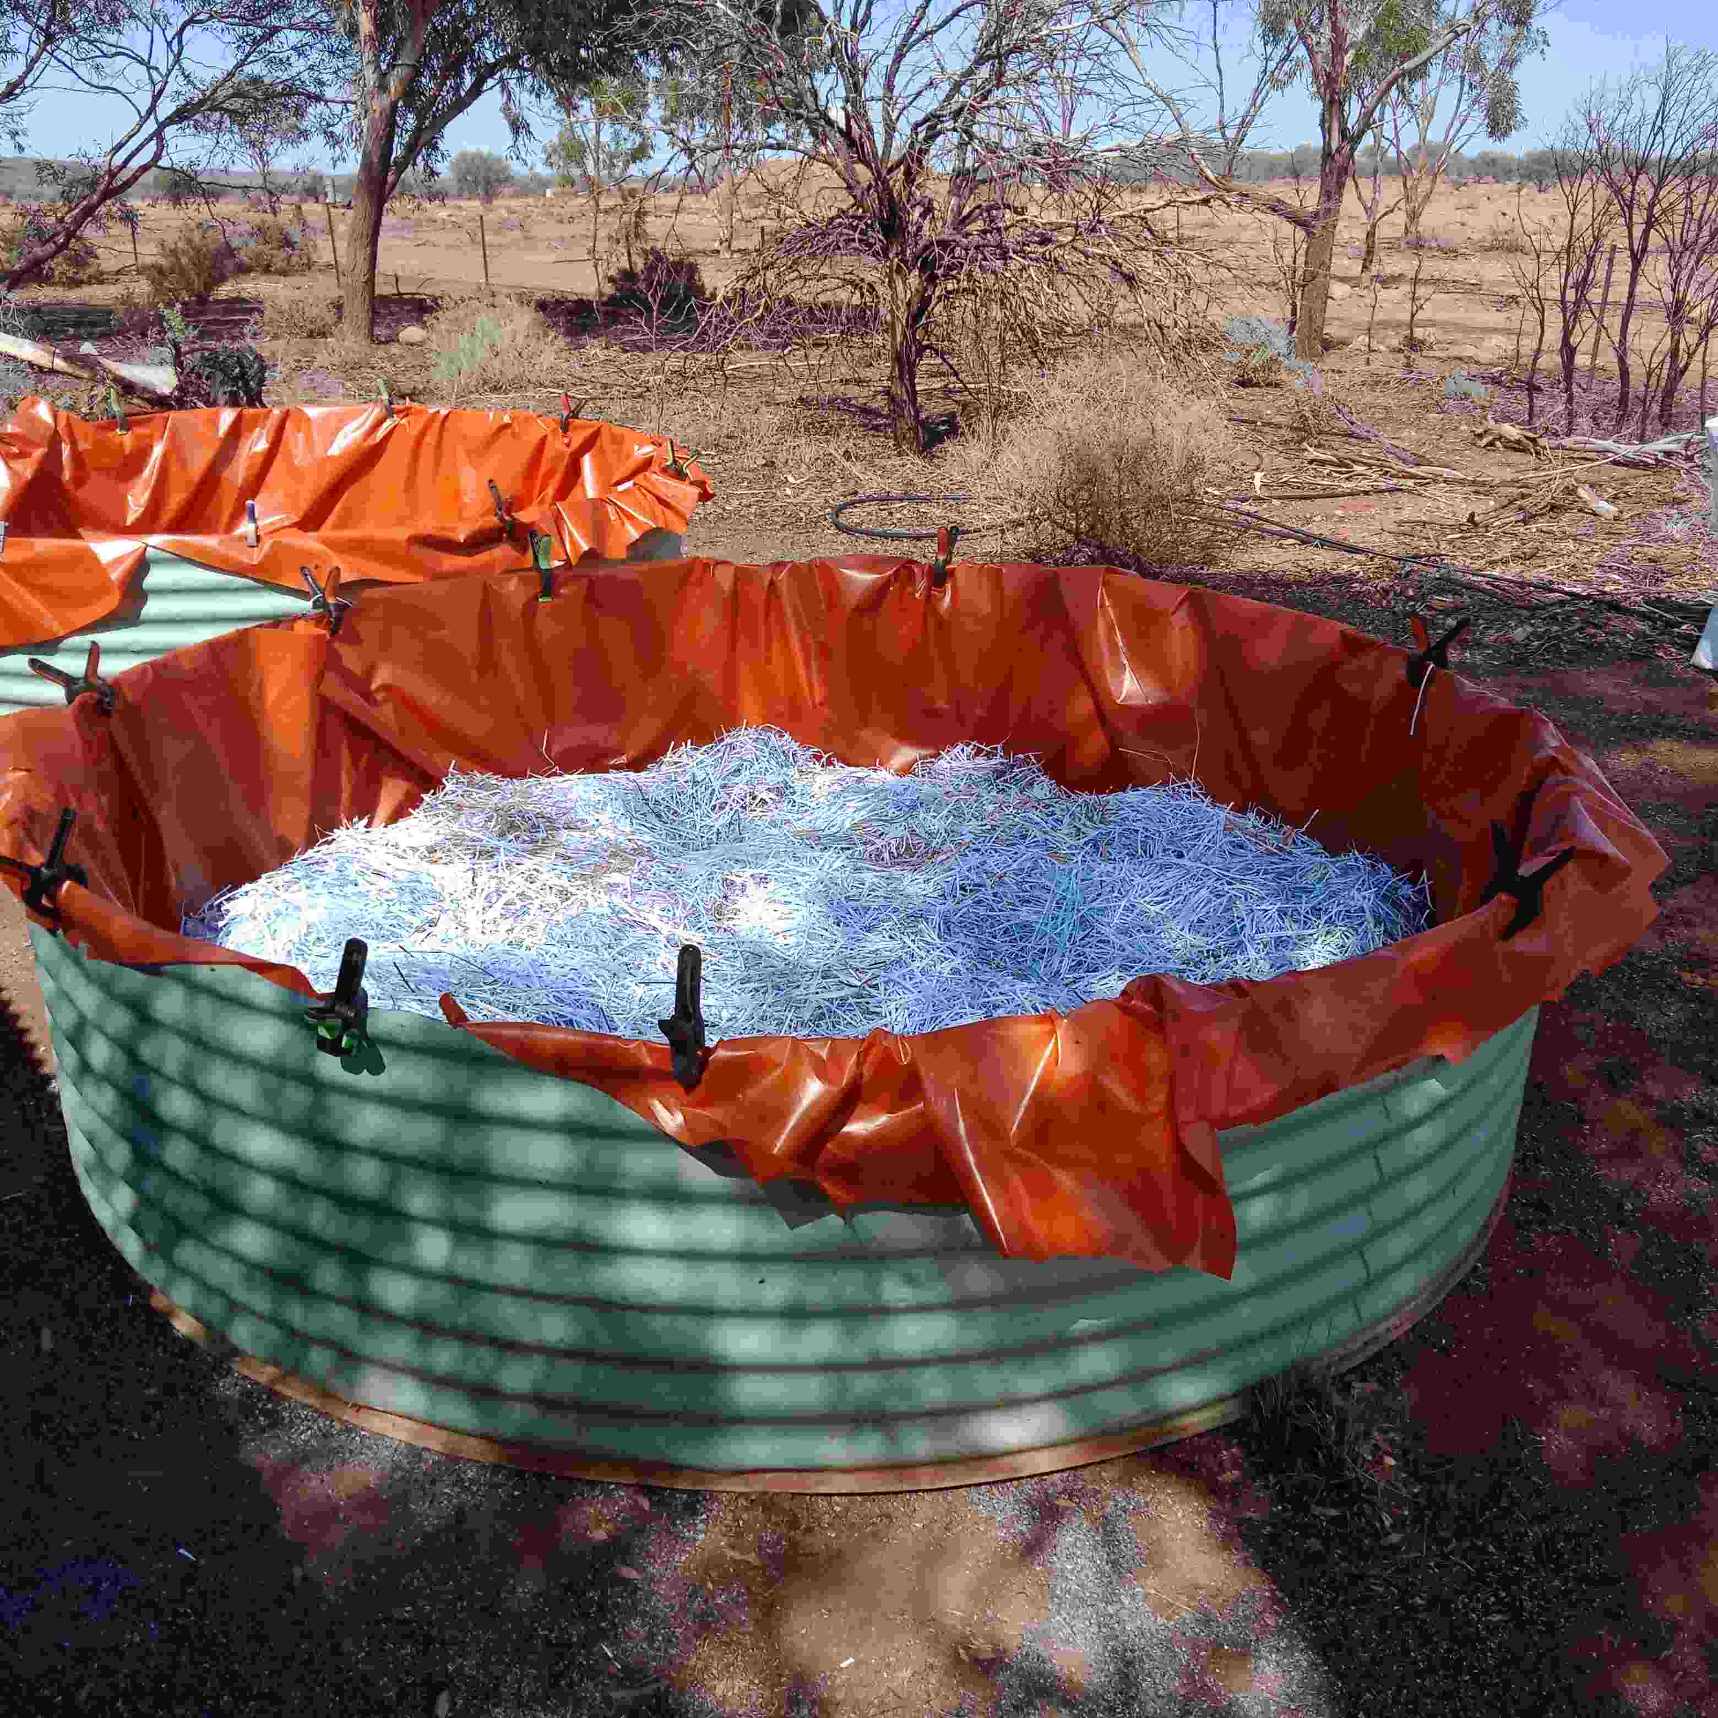

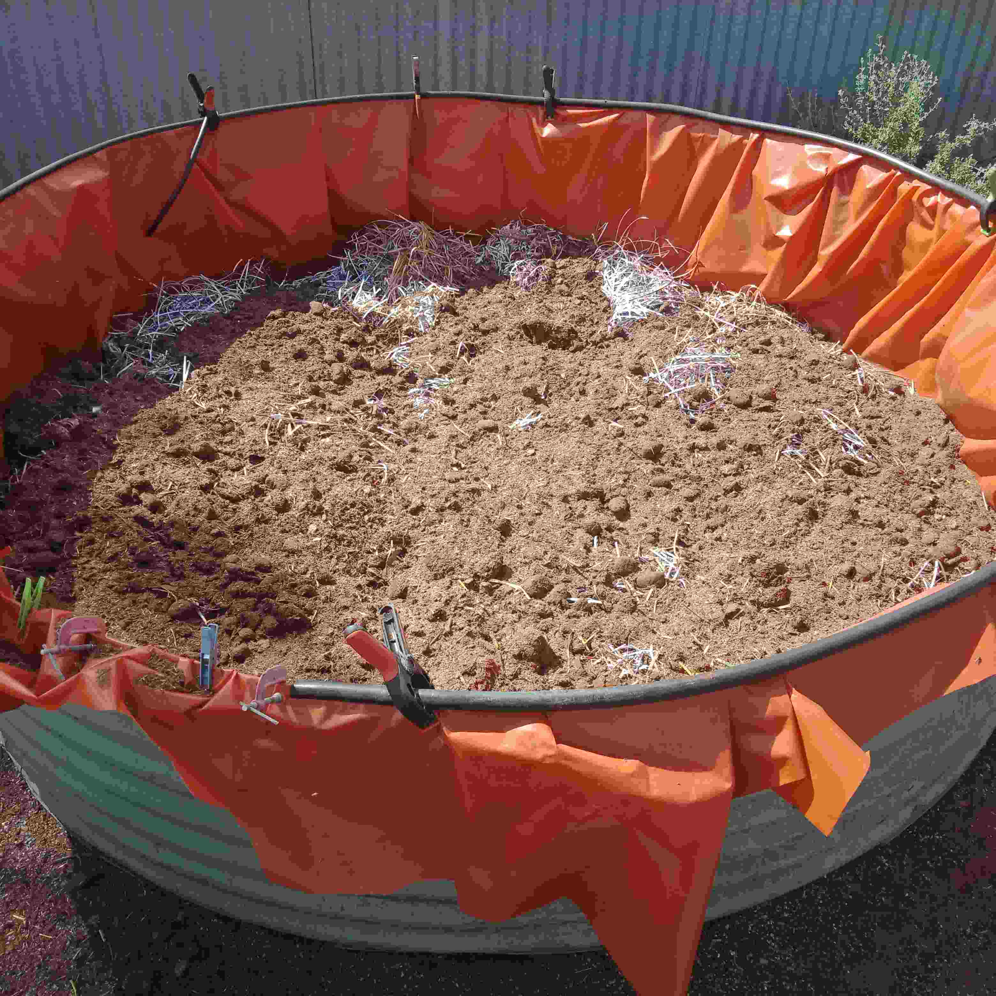 | You then proceed to fill your tank ring or other container with a 50/50 mix of soil, sand and organic waste (compost or mulch) such as that which has a large proportion of straw (pea straw is the absolute best).  We use horse manure as our 50/50 mix with the original soil. Always ensure your oldest horse manure is upper most nearest the growing layer, and the younger or fresher manure is deepest to allow it to age.  Over time such composting organic material will reduce the pH, taking the level down towards the desirable neutral range of 7 to 6. The more organic compost and mulch the better. Sulphur also reduces alkalinity. Tip: check the pH of bought soil.  So, to help this process, it is really worthwhile to sprinkle agricultural powdered sulphur into your soil mix as you fill your tank, with a final surface scatter.

Aiming to leave air space of at least 3 tank rings above your mixed soil surface, continue to fill your tank or container, choosing your better growing mix as you approach your upper level. The air space you leave below the top of your tank or container protects young plants from wind and acts as guard against wayward rabbits  Finally, set up a dripper system, using mud-ant resistant polytube, so that once your veggie seedlings are up, you continue to water via dripper rather than a surface spray. The dripper will lessen the evaporation and airborne water drift and ensure the water goes direct to the plants.  All excess water will percolate down to the well area in the lower reaches of the tank or container. The plant roots will tend to grow deeper to reach the well and as a consequence, when the surface ambient conditions become hotter, the plants will draw more water up from the well contained at the bottom of the tank, thereby ensuring maximum water conservation. | 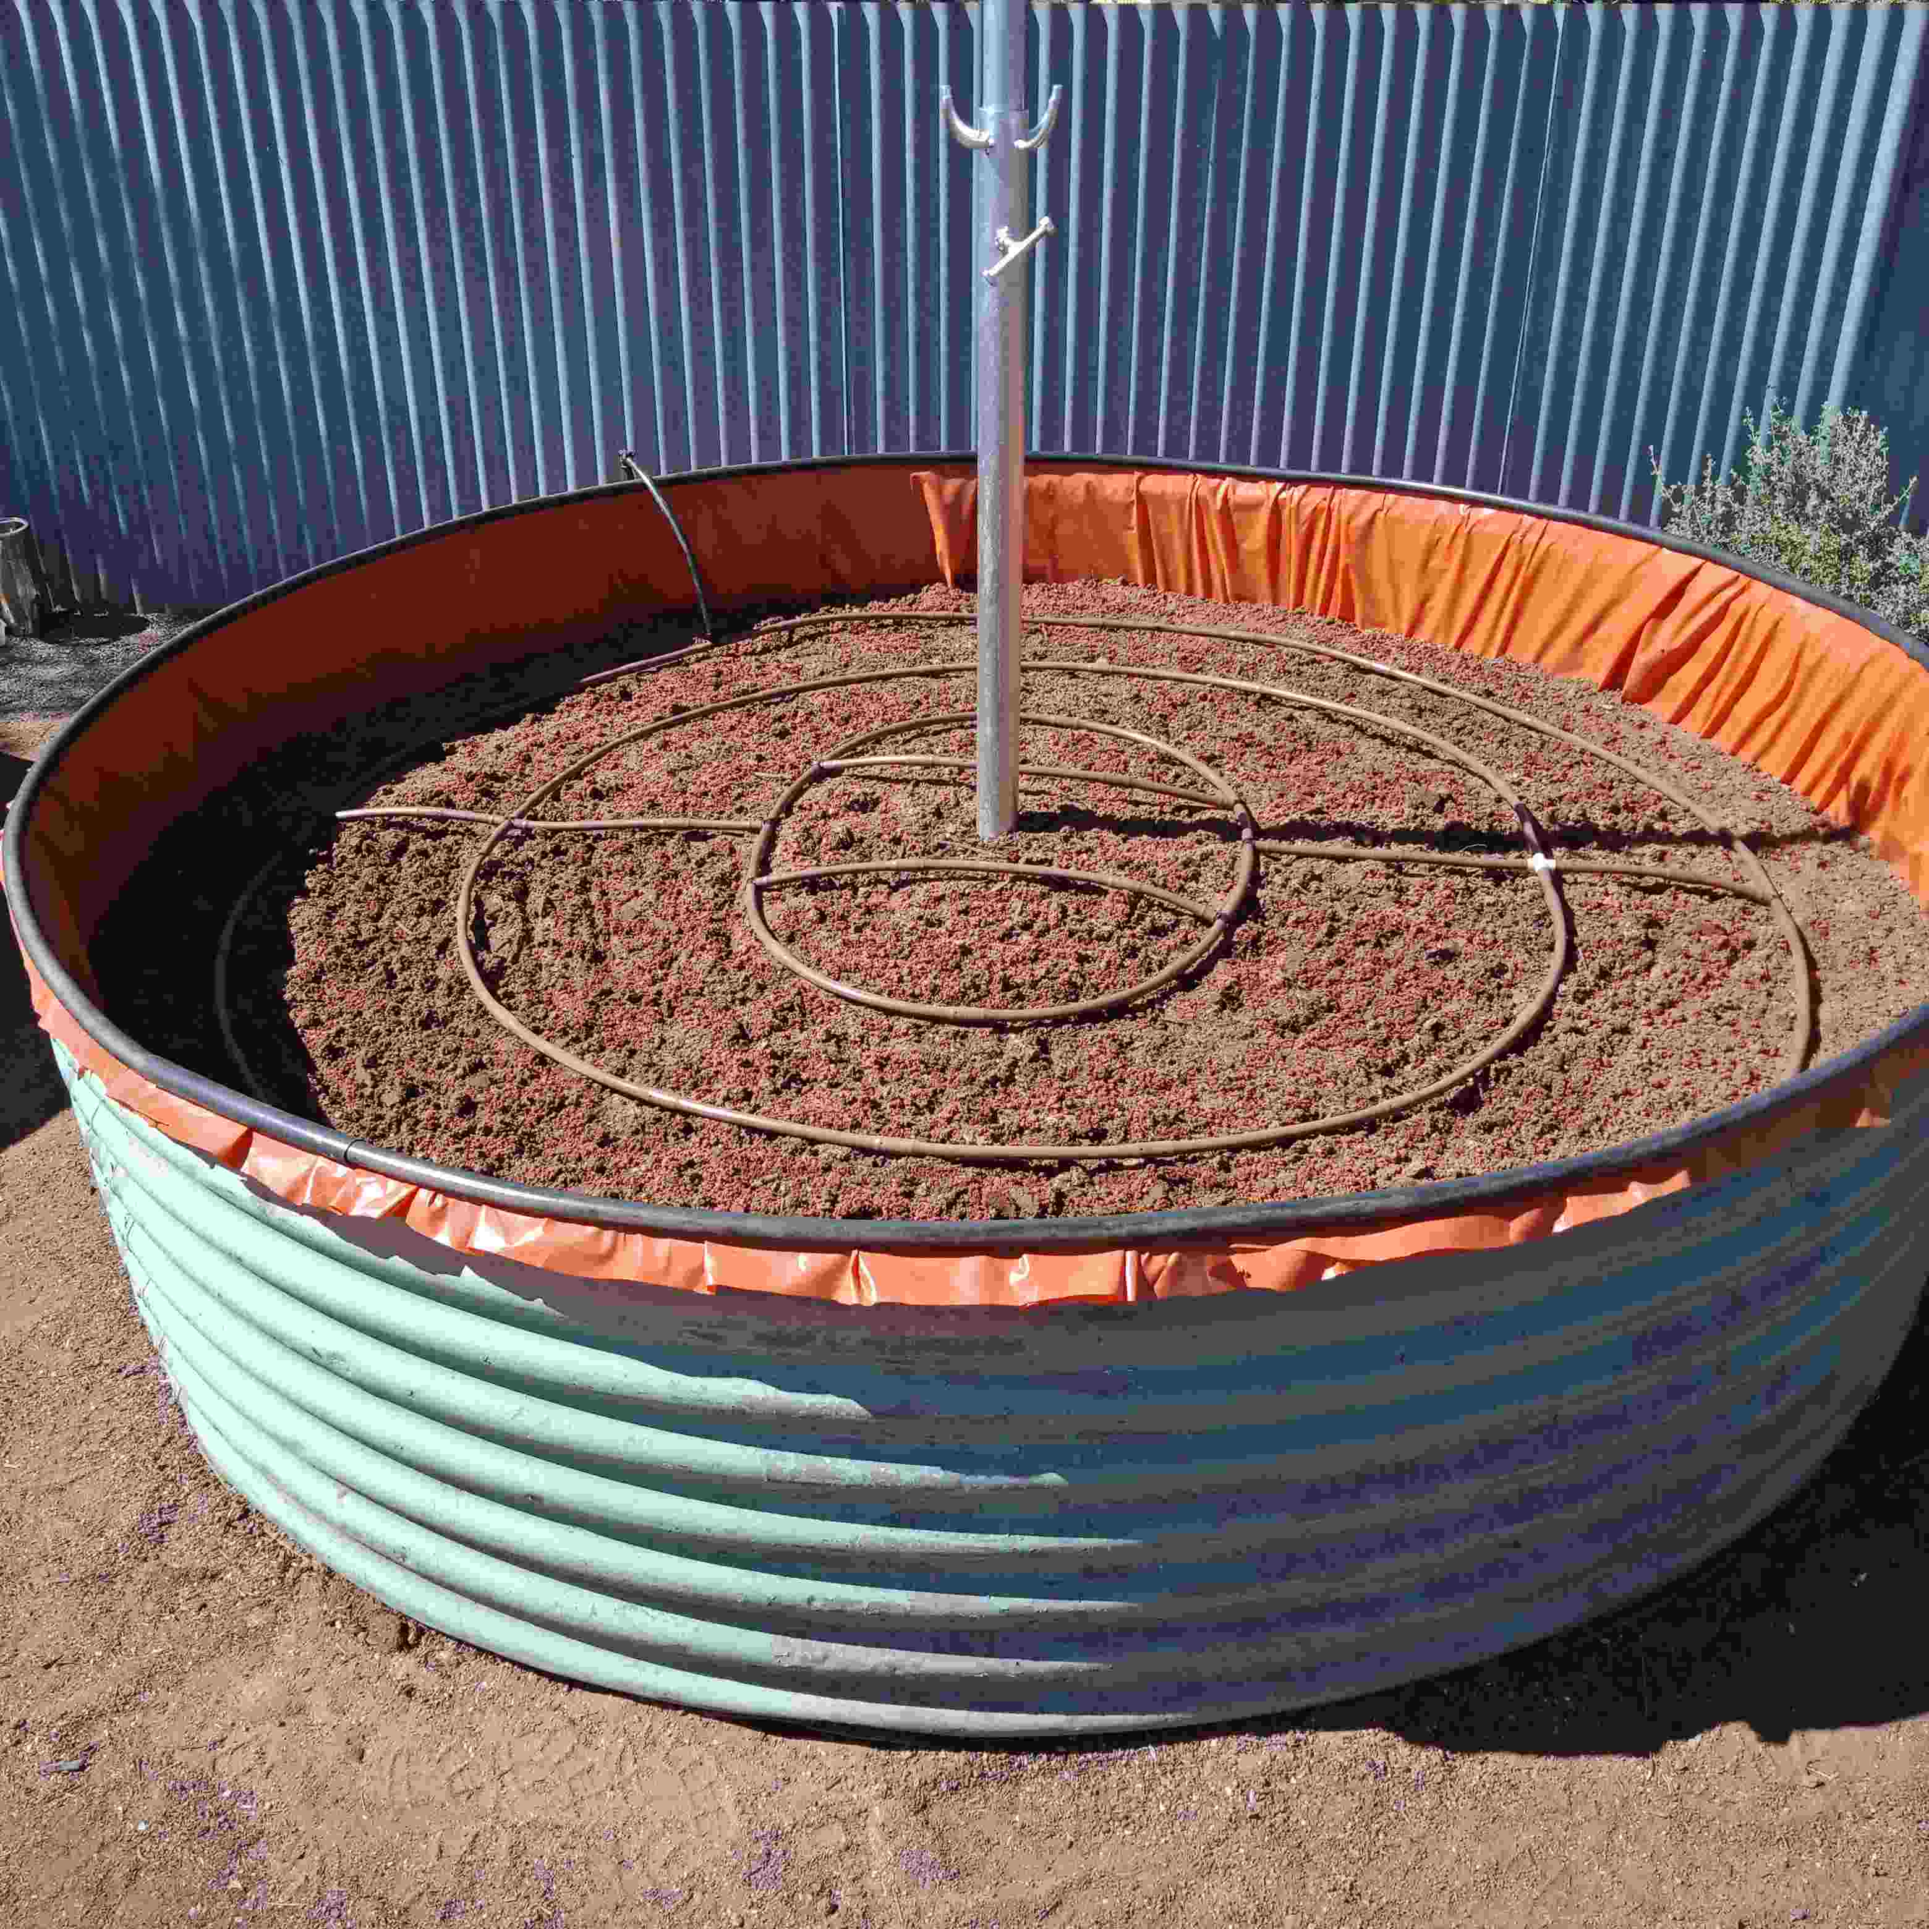

Next week, I will again focus on opportunities for the Broken Hill community to achieve greater self-sufficiency, greater frugality, less wastefulness and more old-fashioned modes of self-reliance.

My intention on focussing on these Home Projects is to encourage listeners to adopt a more sustainable lifestyle – which is good for us all: your hip pocket and the environment!

All Landcare Broken Hill’s public meetings have been cancelled for the foreseeable future due to COVID-19.

All Landcare Broken Hill’s on-the-ground projects have been deferred until further notice, although ‘backroom’ planning and preparation continues.

FACEBOOK: www.facebook.com/LandcareBrokenHill/
WEBPAGE: www.LandcareBrokenHill.com
SoundCloud: https://soundcloud.com/user-296305727 - where ABC interviews live on!
Email: LandcareBrokenHill@gmail.com
POST: PO BOX 536, BROKEN HILL, NSW, 2880

